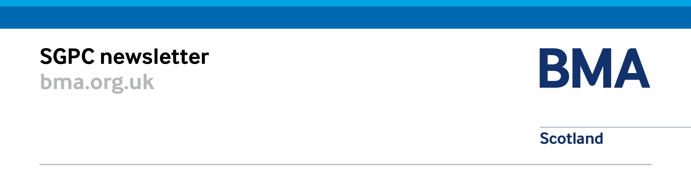
SLMC Update – July 2019
Contents
Negotiating issues and contracts 1
Employers Superannuation Contributions 1
GP sustainability loan application and scheme 1
SPPA AA & Scheme Pays Guidance 2019 – Scottish General Practitioners 1
Primary Care Improvement Plan 2
PCIP and Tracker meetings 2
GP Clusters 2
Workforce 2
Data Collection 2
Information Management and Technology 2
GP IT Re-Provisioning 2
Scottish Joint GP IT Group 2
For information 2
Whistleblowing 2
Sturrock Review: Allegations into bullying and harassment 3
GP Wellbeing 3
Increasing Undergraduate Education in Primary Care 3
LMC and GP Subcommittee board visits 3

Negotiating issues and contracts

Employers Superannuation Contributions
Agreement has been reached that the interim solution to ensure no practice would be out of pocket as a result of increased employer superannuation contributions will now been made permanent. The Scottish Government has been left with a shortfall of £48 million across the public sector as a result of these changes but has agreed to make up these costs.

GP sustainability loan application and scheme
The terms of the GP sustainability premises loans are still being finalised but are now nearing completion.
We anticipate this process being completed in the very near future.

SPPA AA & Scheme Pays Guidance 2019 – Scottish General Practitioners
Two documents from SPPA were recently distributed to GP practices through their LMC medical secretaries on 26 June, the two important aspects to note are: that all GPs should request a Pensions Savings Statement (PSS) from SPPA before 6 July 2019. Any requests for PSS after this date could take up to 3 months to be provided; and any GP that expects that they will have an Annual Allowance bill (tax charge) should submit a Scheme Pays form using provisional figures. The deadline for Scheme Pays elections is 31 July 2019 for tax year 2017/18.

Primary Care Improvement Plan
The second iteration of PCIPs and health board local implementation trackers have been submitted to Scottish Government. Scottish Government and SGPC are carrying out some initial analysis of the data to pull out trends and local and national methods progress of primary care reform across their localities, and in line with service transfer as set out within the Memorandum of Understanding. Both the trackers and the PCIPs will be discussed at the next National GMS Oversight meeting which is scheduled for September. The next submission of the tracker is due in October 2019.

PCIP and Tracker meetings
Two meetings have been scheduled on Thursday 4 July and Thursday 7 November, (11-4pm) at BMA Scotland offices. The purpose of these meetings will continue to focus heavily on PCIP and trackers and are intended for individuals who were most in involved in this work within GP subcommittee and LMC. This could be the LMC Chair, GP Sub chair or medical secretary. The completed PCIP2s and trackers will aid in the discussion of progress within each board area and allow colleagues to network and share any learning from the progress made so far in implementation.

GP Clusters
National Guidance for GP Clusters was published in June 2019 which was developed collaboratively as a resource to support GP Clusters by representatives of Scottish Government, SGPC, RCGP, and informed by Healthcare Improvement Scotland and Scottish Primary Care Clinical Leads.

Workforce

Data Collection
Plans to collect practice data to inform negotiations on the second phase of the new GP contract will progress soon with the coming launch of a General Practice Data Collection Tool that NHS National Services Scotland has developed. Understanding the effect of geography, list size, the makeup of the practice population, etc. on the cost of providing primary care services and the actual cost of running a GP practice, whether in an urban or rural setting, is essential to negotiating a contract that meets the needs of GPs and their patients across Scotland. Personal data will be held securely by NSS and only provided to the negotiating parties in aggregated form. Individuals’ data will subsequently be deleted upon completion of negotiations.

Information Management and Technology

GP IT Re-Provisioning
The three suppliers EMIS Health, Microtest and Vision Health are currently finalising their proposed GP IT systems to meet tranche 1 requirements. Once the systems have met the requirements the cohorts can submit their criteria for mini competitions. At present LMCs should be working with their Boards to form cohorts with criteria that match the requirements of practices. Further details can be found on the NHS Scotland GPIT FAQ page.

Scottish Joint GP IT Group
The fourth meeting of the Scottish Joint GP IT Group was on 9 May and received presentations on a framework on CQL/PQL data access and the MDT Digital Enablement work in more detail. The next meeting is on 15 August and will receive a presentation on progress of eHealth/ digital elements of the vaccination transformation programme. The remit of the group is to support a coordinated strategic approach to GP information management and communications technologies projects within the NHS.

For information

Whistleblowing
Rosemary Agnew, the Scottish Public Service Ombudsman (SPSO) and John Stevenson, Head of Improvement, Standards and Engagement were invited to present to SGPC on 20 June regarding the progress and the work on the Independent National Whistleblowing Officer. The role of the INWO will be undertaken by Rosemary herself, the SPSO and the service aims to ensure that everyone delivering NHS services in Scotland is able to speak out to raise concerns when they see harm or wrong-doing putting patient safety at risk, or when they become aware of any other forms of wrongdoing.
A national leadership role, the INWO has powers to make recommendations for action to be taken and provide support and guidance to relevant bodies with a focus on early resolution where possible, recording, reporting, learning and improvement.
The INWO can also develop and publish National Whistleblowing Standards for NHS service providers. The consultation on the draft national whistleblowing standards ended on 28 June 2019 and the BMA have provided a national response on the standards. An overview of the consultation is available online.

Sturrock Review: Allegations into bullying and harassment
The Sturrock Review published in May 2019 was discussed at the last SGPC meeting on the 20 June, where Dr Iain Kennedy from Highland LMC provided a summary of the key themes, quotes and conclusions of the “Cultural issues related to allegations of bullying and harassment in NHS Highland: independent review report” which was produced by John Sturrock, QC.

GP Wellbeing
The GMC/NES Scottish Advisory Group for the Wellbeing of the Medical Profession is continuing to meet to discuss provision of a Wellbeing service for all Medical Practitioners. Deputy Chair, Dr Patricia Moultrie is leading on the GP aspect of the work within the Advisory Group with Dr Carey Lunan, RCGP. SGPC will continue to explore provision of a mental health service for General Practitioners in Scotland.
In addition to addressing GP workload through implementation of the new contract SGPC are concentrating their efforts on two main aspects of GP Wellbeing, provision of accessible mental health services and reducing the burden of appraisal with the aim of making it a more supportive interaction which will positively impact on recruitment and retention of GPs in Scotland.

Increasing Undergraduate Education in Primary Care
A final report of the Increasing Undergraduate Education in Primary Care group will be published imminently. Recommendations expected within the report included a recommended rate increase of ACT funding to help in recruitment and retention of educator GPs.

LMC and GP Subcommittee board visits
The SGPC Negotiating team are keen to engage with LMCs and see the progress of implementation first hand. The team have visited Forth Valley and Orkney recently and Ayrshire & Arran in the past and are due to visit some practices in Highland: Wick, Caithness, Sutherland and Wester Ross and will also visit the Borders. They have discussed local needs of areas, and shared learning and knowledge from other areas as well as taking a wealth of knowledge from each visit. If your LMC is also interested in a visit from our team, please do get in contact with us at info.gpscotland@bma.org.uk. We would welcome the chance to arrange a visit to your area.

LMCs are reminded they can contact Andrea Ma, SGPC secretariat for more details (ama@bma.org.uk).
Our SGPC Negotiating Team
Dr Andrew Cowie  Deputy Chair, SGPC | Dr Andrew Buist  Chair, SGPC | Dr Patricia Moultrie  Deputy Chair, SGPC

Any emails for the SGPC negotiating team should be submitted to info.gpscotland@bma.org.uk
Your ideas about achievable measures to reduce pressure on general practice are always welcome.
We can’t respond to every email, but all emails are read and considered by the team.

